PROFILE
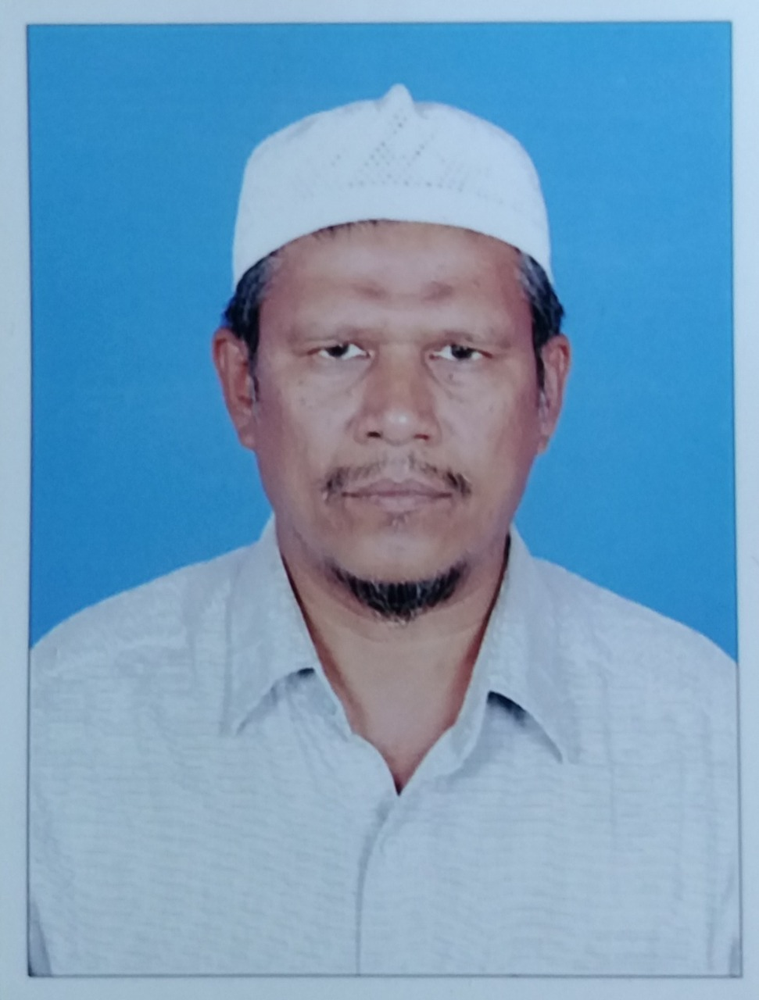
1. Name: M.KHAJAMIDEEN.
2. Date of Birth: 15-02-1961
3. Address:
Residential: Office:
53,KAVERY NAGAR, DEPARTMENT OF ARABIC,
WIRELESS ROAD, JAMAL MOHAMED COLLEGE,
AIRPORT, TIRUCHIRAPPALLI-20.
TRICHY.
Pin Code:620007
Mobile: 9786601422
Email: kmarabic@yahoo.com
4. Designation: Associate Professor
5. Educational Qualifications:
Examination Passed Year
M.A. 1984
M.Phil 1985
PhD 2014

6. Experience: Under Graduate: 35 Years
Post Graduate : 34 Years.
M.Phil : 07 Years

7. Areas of Specialization:
Arabic Grammar, Comparative Grammar.
8. Languages Known: Arabic, English and Tamil.
9. Subjects Taught:
Under Graduate: Prose, Poetry, Grammar and Islamic History.
Post Graduate: Modern Prose, Islamic Philosophy, Grammar,
M.Phil: Research Methodology, Literary History
10. Research Supervision:
MPhil.Degree:- Completed: 8
11. Publications:
Articles Published in Academic Research Journals: 2
12. Details of Seminars attended (without Presenting Paper)- 12
13. Details of Seminars Organised:1

14. Details of Orientation /Refresher Courses attended.
Orientation Course: 1 , Refresher Courses: 3

15. Details of Study Materials /Books Written and Published:

16. Administrative Positions held in the college:
Secretary of Baithulmal Society.
Advisor: Student Exnora,Gender Club,Citizen Consumer Club and Red Ribbon Club.

17. Membership in Committees for autonomous Programme Implementation:
Examination Committee.

18. Participation in Extra Curricular Activities:
Student Exnora,Gender Club, Citizen Consumer Club and Red Ribbon Club.

19. Details of Participation in Consultancy, Training, and Development etc…
Visa translation and other documents translation for abroad countries and training students.

20. Details of Membership in Academic Bodies:
Chairman, Board of Studies,BARD standing committee member.
Placement Officer.

23. Countries Visited: Saudi Arabia.

24. Other Information:
1.Chairman – Board of question paper setters in UG and PG,University of Madras.
2.Member- Board of question paper setters in Afzal-ul-ulama, University of Madras.
3.Member- Board of question paper setters in Arabic A.D.M. College(auto), Nagapattinam.
4. Member- Board of question paper setters in Arabic, Sadakathullah Appa College,Tirunelveli.
5. Member- Board of question paper setters in Arabic, Madurai Kamarajar University.
6. Member- Board of question paper setters in Arabic Tasumbeevi College for Women,Keelakarai,Ramanad District.
7.Co-ordinator-(CDE) Arabic Pandit Training Course at BARD.

